**1.** Determine all joint possibilities listed below from the following information:

$P(A)=0.74, P(A^{c})=0.26, P(B|A)=0.49, P(B|A^{c})=0.8$

$P(A and B)$

$P(A and B^{c})$

$P(A^{c} and B)$

$P(A^{c} and B^{c})$

The $A^{c}$ means $A'$, or the complement of *A*, or $1-P(A)$. When the probability of event *A* and *B* are asked, this means their probabilities are multiplied together, because they are a 2 element list. The “|” means given (what is the probability of A, given that B has happened); in other words, if asked for $P(A|B)$, this would equal $\frac{P(A\&B)}{P(B)}$.

Part A

You can use this to find the probability of *A* and *B*. So, let’s use $P(B|A)=\frac{P(B\&A)}{P(A)}$. Remember, due to multiplication (commutative property), *P(A and B) = P(B and A)*. Input the given values: $0.49=\frac{P(B\&A)}{0.74}$ and solve for the probability, so you get **0.3626**.

Alternatively, this is also equal to $P(B|A)×P(A)$, which is the same thing done here.

Part B

Since $P(B and A)=P(B)×P(A)$, you know what *P*(*A*) is, and you’ve figured out what the probability of both events are, you can solve for $P(B)$, then find its complement. So, $0.3626=P(B)×0.74$, so solve and get 0.49 for *P*(*B*). The compliment is therefore 0.51.

So, multiplying *B*’s complement and A is equal to **0.3774**. Alternatively, this is also equal to $P(A)-P(A and B)$.

Part C

Do the same as Part B here but with the last probability information. $0.8=\frac{P(B and A')}{0.26}=$ **0.208**. Alternatively, this is also equal to $P(B|A')×P(A')$.

Part D

Add all the previous answers and subtract that sum from 1 (total possibility) to get **0.052**. This is because you want not A and not B, so you have to subtract all the other possible outcomes (which are the other answers) from 1 to get this.

[Alternative way to solve this problem](https://www.algebra.com/algebra/homework/Probability-and-statistics/Probability-and-statistics.faq.question.1119951.html)

**2.** An elementary school is offering 3 language classes: one in Spanish, one in French, and one in German. These classes are open to any of the 95 students in the school. There are 30 in the Spanish class, 26 in the French class, and 22 in the German class. There are 11 students that are in both Spanish and French, 4 are in both Spanish and German, and 6 are in both French and German. In addition, there are 2 students taking all 3 classes.

1. If one student is chosen randomly, what is the probability that he or she is not in any of these classes?
2. If two students are chosen randomly, what is the probability that both of them are taking French?

Part A

Let *S* denote all possible students that can be chosen, which is equal to 95 (this is a subset, but it’s a given: 95 choose 1; order doesn’t matter but repetition is not allowed). This will be the sample size of all the probabilities. For this, you should find the probability that students are in one of the language classes, then use the complement to find the probability that students are not in a class.

You have to use Principle of Inclusion and Exclusion because there are overlaps (people taking multiple classes). So, you have to add the probability of each individual event (Spanish [E], French [F], and German [G]), then subtract the intersections found. This would reflect the three sets in the notes.

$\frac{30}{95}+\frac{26}{95}+\frac{22}{95}-\frac{11}{95}-\frac{4}{95}-\frac{6}{95}+\frac{2}{95}=\frac{59}{95}$

$1-\frac{59}{95}=$**36/95**

Part B

Out of 95 students, there are 26 taking French. It doesn’t matter if they’re taking other language classes as well; all you care about is if they’re taking French.

Let ($a_{1},a_{2}$) to represent the 2 students as a 2 element tuple, where order matters and repetition is allowed (the person can take the same class, I believe). You could multiply the probabilities together with the Product Principle to get the total probability. The probability of each student would have to be multiplied together, This is a permutation because the order of the students chosen matters (you would have to minus 1 person from the total number of students) and repetition is not allowed (you can’t choose the same person twice).

Thus, making to subtract one appropriately for the second student, $\frac{26}{95}×\frac{25}{94}=$**65/893**.

**3.** For the given letters “AAABBBCC”,

1. Find the number of distinguishable permutations.
2. If a permutation is chosen at random, what is the probability that it begins with at least 2 A’s?

Part A

Remember, this is like an anagram. Count how many of each letter there are. Here, there are 3 A’s, 3 B’s, and 2 C’s. If you distinguish each letter to be different, then the number of permutations of the whole thing is 8!.

Next, you need to define an equivalence relation *R* where permutations that match the same in English don’t count twice (see more on page 27 under Counting Equivalence Classes). Each equivalence class of the relation consists of 3 permutations where you can swap 3 A’s, 3 permutations where you can swap 3 B’s, and 2 permutations where you can swap 2 C’s. You can multiply these together thanks to Product Principle.

Use the quotient principle to count equivalence classes, so it would be $\frac{8!}{3!3!2!}=$**560**.

Part B

First, understand that there needs to be at least 2 A’s in the beginning. Since 2 letters are already decided for you, you can subtract those from the size on the numerator of Part A and subtract 2 from the first 3!, so you would get $\frac{6!}{1!3!2!}=$ 60 permutations.

However, to find the probability, put these possible outcomes over the total amount of outcomes, which was found in Part A to get **60/560**.

**4.** A bag contains 7 red marbles, 7 white marbles, and 9 blue marbles. You draw 5 marbles out at random, without replacement.

1. What is the probability that all marbles are red?
2. What is the probability that exactly 2 of the marbles are red?
3. What is the probability that none of the marbles are red

Part A

First, you need to find the sample size. When talking about sample size, the order of the marbles doesn’t matter, and repetition of marbles is not allowed. So, this is $(23 choose 5)=33649$.

Probability is basically the number of desired outcomes over the total number of outcomes. You need to count the number of desired outcomes. The number of desired outcomes is also a subset because the order of choosing the red marbles doesn’t matter (they’re all red) and the repetition of the marbles is not allowed, so this is $(7 choose 5)=21$ because you’re choosing 5 of the total 7 red marbles.

Thus, this is **21/33649**.

Part B

Similar to Part A, the sample size is the same. This is a multiset, where the order doesn’t matter (can choose the not-reds first, then the reds) and repetition is allowed (but not necessary).

Choosing exactly 2 is a subset in itself because it doesn’t matter which red marble you choose, as long as it’s red, and repetition is not allowed. Thus, $(7 choose 2)$ because there are 7 reds, which is equal to 21.

Since you don’t want to pick anymore red ones, subtract 7 reds from the total to get 16. You still have to choose 3 other marbles (the second subset of the list). So, $(16 choose 3)=560$.

Using product principle (it’s part of a multiset), you can multiply them together to get 11760. This is the number of desired outcomes, then put the sample space underneath: **11760/33649**.

Part C

If none of the marbles chosen are red, you must subtract 7 red marbles from the total number of outcomes (23) for each slot. So, this would be $\frac{16}{23}×\frac{15}{22}×\frac{14}{21}×\frac{13}{20}×\frac{12}{19}=$**624/4807**. This is equivalent to doing $(16 choose 5)/(23 choose 5)$ using subsets.

**5.** The data below was obtained from a random survey of 427 people. The participants were asked their political party and whether they approve, disapprove, or have no opinion on how the president is doing his job. The results are as follows:

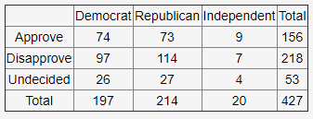

If a person is selected at random, what is the empirical probability that the person approves of the job the president is doing or is an independent?

Empirical probability refers to a problem that is based on historical data (the likelihood of an event occurring based on historical data), according to the [CFI](https://corporatefinanceinstitute.com/resources/knowledge/other/empirical-probability/). The formula is:



where the numerator refers to the number of times the desired event occurred, and the denominator refers to the total amount of times the event was performed.

In this problem, the experiment is performed 427 times (where each person answered counts as 1 experiment). For an “or”, the number of favorable events is added (minus when they both intersect), so $156+20-9=167$.

Thus, the probability is **167/427**.

**6.** Suppose that *A* and *B* are two events for which $P(A)=0.27, P(B)=0.71,$ and $P(B|A)=0.41$. Find each of the following:

$P(A and B)$

$P(A or B)$

$P(A|B)$

Part A

This is equal to $P(A)×P(B|A)=(0.27)(0.41)=$**0.1107**.

Part B

This is equal to $P(A)+P(B)-P(A∩B)=$**0.8693**.

Part C

Use Bayes’ Theorem:



$P(A|B)=\frac{(0.41)(0.27)}{(0.71)}=$**0.155915493**.

Solved with the help [of this website](https://www.cbsd.org/cms/lib/PA01916442/Centricity/Domain/1912/Probability%20rules%20worksheet%201%20KEY.pdf).

**7.** A box contains one yellow, two red, and three green balls. Two balls are randomly chosen without replacement. Define the following events:

A: { One of the balls is yellow }

B: { At least one ball is red }

C: { Both balls are green }

D: { Both balls are of the same color }

Find the following conditional probabilities:

$P(B|\underline{A})$

$P(D|B)$

$P(D|\underline{C})$

*A*: The probability for getting a ball that’s yellow on the first draw is $\frac{1}{6}×\frac{5}{5}=\frac{1}{6}$. For getting it on the second draw, $\frac{5}{6}×\frac{1}{5}=\frac{1}{6}$. The probability of *A* is getting the yellow ball the first draw OR the second, so you can add the probabilities together to get $\frac{1}{3}$. The complement of this is $\frac{2}{3}$.

*B*: The probability that no balls are red is $\frac{4}{6}×\frac{3}{5}=\frac{12}{30}$. The actual probability of *B* is $1-\frac{12}{30}=\frac{3}{5}$.

*C*: The probability is represented by $\frac{3}{6}×\frac{2}{5}=\frac{6}{30} or \frac{1}{5}$. The complement of this is $\frac{4}{5}$.

*D*: There are 3 colors, so find out the probabilities for each instance of color and add them all together (because either both yellow, both red, OR both green balls) to get $0+\frac{1}{15}+\frac{1}{5}=\frac{4}{15}$:

Yellow: 0 (because there is only one yellow ball)

Red: $\frac{2}{6}×\frac{1}{5}=\frac{1}{15}$

Green: $\frac{1}{5}$ (found in *C*)

Part A

This means that the probability that at least one ball is red given that there are no yellow balls chosen.

The probability the first ball is red and the second is another color BESIDES yellow and red is represented by $\frac{2}{6}×\frac{3}{5}=\frac{6}{30}=\frac{1}{5}$.

The probability the first ball is a color BESIDES yellow and red and the second ball is red is represented by $\frac{3}{6}×\frac{2}{5}=\frac{1}{5}$.

The probability that both balls are red and NOT yellow is represented by $\frac{2}{6}×\frac{1}{5}=\frac{1}{15}$.

Because $P(B|\underline{A})=P(B∩\underline{A})/P(\underline{A})$, add these probabilities together (notice the AND in the numerator), so $(\frac{1}{5}+\frac{1}{5}+\frac{1}{15})/(\frac{2}{3})=$**7/10**.

Part B

$P(D|B)=P(D∩B)/P(B)$, so you have to find the AND, which is the probability that both balls are the same color AND at least one ball is red.

There is only one given scenario for this, and that is when both balls are red found in Part A, which is $\frac{1}{15}$.

$P(D|B)=(\frac{1}{15})/(\frac{3}{5})=$**1/9**.

Part C

$P(D|\underline{C})=P(D∩\underline{C})/P(\underline{C})$, so you have to find the AND probability: the probability that both balls are the same color AND both balls are NOT green, so this is just adding the other probabilities of both colors and not the green, which is $0+\frac{1}{15}=\frac{1}{15}$.

$P(D|\underline{C})=(\frac{1}{15})/(\frac{4}{5})=$**1/12**.

**8.** In a survey of 175 people, the following data was obtained relating gender to political orientation:

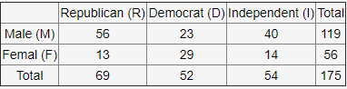

A person is randomly selected. What is the probability that the person is:

1. Male?
2. Male and a Democrat?
3. Male given that the person is a Democrat?
4. Republican given that the person is Male?
5. Female given that the person is an Independent?
6. Are the events Male and Republican independent? Enter yes or no.

Part A

The number of total outcomes is 175, and the number of desired outcomes is 119. So, this is **119/175**.

Part B

Find the box that has both male and Democrats, which is **23/175**.

Part C

Here, this is conditional probability. The probability of both events occurring is given in the last part, so all you need to do is divide that number by Event B, or in this case, the probability of being a Democrat (52/175) to get **23/52**.

Part D

Same as Part C, except now the numerator is now 56/175 (both Republicans and males), then divide that by 119/175 (the probability of being a male) to get **56/119**.

Part E

Same as Part C, except now the numerator is 14/175 (both females and Independents), then divide that by 54/175 (the probability of being an Independent) to get **14/54**.

Part F

To find if two events are independent, then the following formula must be satisfied: 

P(Male) = 119/175, P(Republican) = 69/175, P(Male and Republican) = 56/175.

$\frac{119}{175}×\frac{69}{175}≠\frac{56}{175}$, so they are not independent events: **no**.

Similar problems depicted [here](https://cseweb.ucsd.edu/classes/wi14/cse21-a/solution8.pdf).

**9.** A new medical test has been designed to detect the presence of the mysterious Brainlesserian disease. Among those who have the disease, the probability that the disease will be detected by the new test is 0.74. However, the probability that the test will erroneously indicate the presence of the disease in those who do not actually have it is 0.12. It is estimated that 14% of the population who take this test have the disease. If the test administered to an individual is positive, what is the probability that the person actually has the disease?

Let

E = the event that an individual has the disease

E’ = the event that the individual does not have the disease

F = the event that the disease test detects the disease in any individual

Then,

$P(E)=0.14$

$P(E’)=1-0.14=0.86$

$P(F)=P(detects AND has the disease) + P(detects AND does NOT have the disease)$

$=P(F|E)P(E)+P(F|E')P(E')$

$=(0.74)(0.14)+(0.12)(0.86)=0.2068$

Afterwards, use the Baye’s Theorem that

 $=\frac{(0.74)(0.14)}{0.2068}=$**0.500967118**.

**10.** If $P(A)=0.1, P(B)=0.3,$ and $P(A∪B)=0.39,$ then

$P(A∩B)$

1. Are events A and B independent? (Enter yes or no)
2. Are A and B mutually exclusive? (Enter yes or no)

Part A

$P(A∪B)=P(A)+P(B)-P(A∩B)$

$0.39=0.1+0.3-P(A∩B)$

$0.39-0.4=-P(A∩B)$

$P(A∩B)=$**0.01**

Part B

$P(A)×P(B)=? P(A∩B)$

$0.1×0.3≠0.01$, so **no**

Part C

Events A and B are mutually exclusive if they both cannot happen ($P(A∩B)=0)$. Since this does not equal 0, this is also **no**.

**11.** Which of the following graphs are connected?

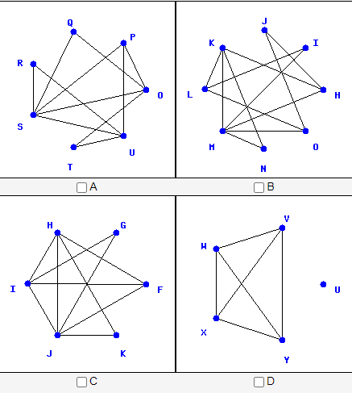

A graph is connected when it has exactly one connected component. You can eliminate D as an option because vertex *U* is a component of itself. For the rest, you can easily tell that they are all connected because no vertex is left unconnected. So, pick the rest of the choices, **ABC**.

**12.** Consider the graph:

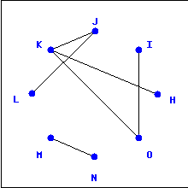

1. What is the order of the graph?
2. What is the degree of vertex *J*?
3. What is the degree of vertex *M*?
4. How many components does the graph have?

Part A

The order of the graph means the number of vertices the graph has. There are **8**.

Part B

The degree of a vertex means how many edges are directly connected to it, where edges are the lines connecting vertices. So, for *J*, the vertices connected to it are *K* and *L*. So, the answer is **2**.

Part C

The only vertex connected to *M* is *N*, so the answer is **1**.

Part D

The number of components is **2** because *M~N* are a separate component than the rest of the vertices (they’re not connected with *J~K~etc.*).

**13.** Which of the following degree sequences are possible for a simple graph?

1. (7,4,3,9,5,4,9,7,8,7)
2. (6,1,5,5,9,1,1,6,1)
3. (7,7,6,4,5,7,5,7)
4. (4,5,2,1,3,3,4)

A simple graph is a graph that has no more than one edge joining two vertices. A degree sequence is the number of degrees a vertex has in a graph with each vertex. For example, *a* has a vertex with 7 edges, and the next one has 4, etc.

[Here](https://youtu.be/aNKO4ttWmcU) in the first few minutes, the graphical sequence is a degree sequence of some graph (meaning a graph exists for the given degree sequence) and may be a degree sequence for more than 1 graph. Since in this course, multigraphs (and therefore loops) are not talked about, you’re just trying to test if a graph exists.

These are the *necessary* conditions (but not sufficient):

* A graphical sequence must have an even number of odd degrees (AKA the sum of degrees must be even).
* The maximum degree of a graphical sequence should not be greater than or equal to the number of vertices (AKA the highest degree can be at most the number of vertices minus 1).
  + This is because if you have *n* vertices in the graph, any given vertex can only be adjacent to at most all other vertices.

The *necessary AND sufficient* conditions (so solve by the Havel and Hakimi theorem):

A sequence of non-negative decreasing ordered degrees (biggest to smallest) and the number of vertices being at least the number of vertices ($n≥2$) and the the first degree in the list being $≥1$, is graphical IF AND ONLY IF the sequence $s_{1}=d_{2}-1, d_{3}-1,...,d_{d_{1}+1}-1,d_{d_{1}+2},...,d_{n}$. Notice that there are $d_{1}$ terms that have a $-1$.

If you get to a sequence of all 0s, then absolutely the sequence is graphical. This is because all 0s means an empty graph (no vertices or edges). Be sure to reorder it so it’s in decreasing order every time. Applying this theorem is done if the necessary conditions are met (so it’s not as much work).

So, let’s apply this to the problems:

Choice A

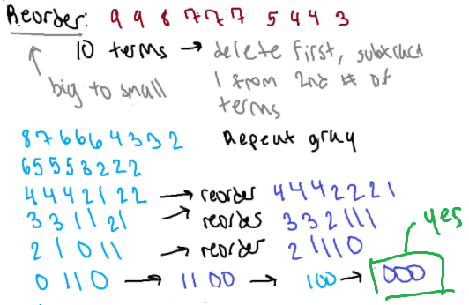

PLEASE NOTE THAT EVEN THOUGH THE THEOREM IS APPLIED, THE NECESSARY CONDITIONS ARE NOT MET **(will have to look into if i’m doing something wrong with the theorem)**

* The sum is 63 here, which is NOT even

Choice B

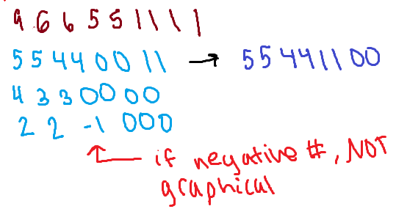

Here, this can be solved without applying the theorem; this sequence does not meet the second condition, or the maximum degree must be 1 less than the number of vertices. Here, 9 is not 9-1, so therefore it’s wrong.

Choice C

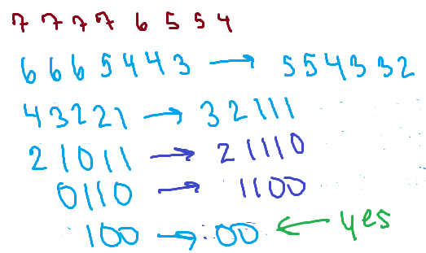

Choice D

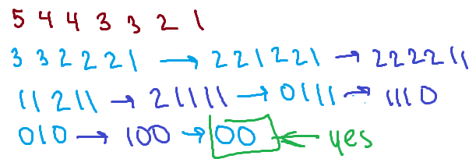

So, the correct choices are **CD**.

**14.** Which of the following are trees and which are forests?

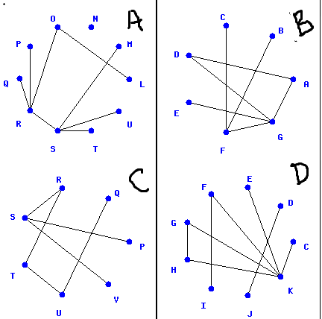

A graph is a forest if the graph has no cycles (can have more than 1 component).

* A forest is a tree. However, a tree is NOT a forest.
* A cycle is a walk of length of at least 3 edges in which the first and last vertex are repeated, but no other vertices are repeated.

A graph is a tree if it has at least 1 vertex and $n-1$ edges where *n* is the number of vertices. It also has no cycles and is connected (meaning only 1 component).

Graph A

This is NOT a tree because it is not connected (notice vertex *N*). To see for cycles, see if any shapes are made by vertices (which there aren’t; a walk of *S~R~O~L* seems like a cycle, but the rectangle does not have four vertices included). **A is a forest**.

Graph B

From first glance, this is neither a tree or a forest because a triangle is formed by the walk *G~A~D*, which is a cycle. So, **B is not a tree and not a forest (don’t check any boxes)**.

Graph C

The number of vertices here is 7. There are 6 edges, which fits the description of a tree. It is also clear that there are no cycles in this graph. So, **C is a forest, C is a tree**.

Graph D

From first glance, like Graph B, there is a triangle formed by the walk *G~H~K*, which is a cycle; so, **D is not a tree and not a forest (don’t click any boxes)**.

**15.** Which of the following graphs have Euler circuits or Euler trails?

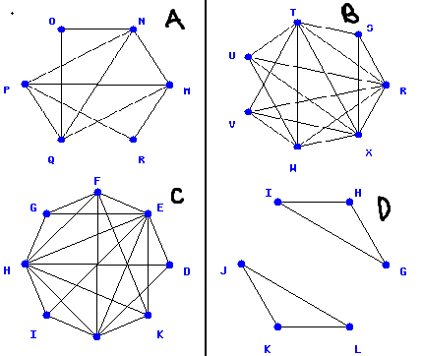

An Eulerian trail (or “path” online) is a walk that traverses every edge exactly once.

* Has at most (most certainly and exactly) 2 vertices of odd degree
* If *G* has an Eulerian trail that begins at vertex *x* and ends at vertex *y* where they’re not equal to each other, then vertices *x* and *y* have odd degree
* Starts and ends at different vertices

An Eulerian tour (or circuit) is a walk that traverses every edge exactly once AND begins and ends at the same vertex.

* *G* has an Eulerian tour if and only if it is connected (to be connected means having only ONE component) AND every vertex has an even degree.

When finding such examples that exist, it may be helpful to number the edges so you make sure each edge is hit only once.

Choice A: First, check the degrees of its vertices: $O=2, N=4, M=4, R=2, Q=4, P=4$. There are no odd degrees, this could not have an Euler trail. However, notice how all the degrees are even. The graph is also connected because there is so it does have an Eulerian tour. **The graph has an euler circuit.**

Choice B: Check the degrees of its vertices: $T=6, S=3, R=6, X=6, W=5, V=4, U=4$. This could be an Euler trail since there are at most 2 degrees, but not a tour because all the degrees are not even. Here, it’s exactly 2 vertices that are odd, which is a factor of an Eucler trail. So, **the graph has an euler trail**.

Choice C: Degrees of its vertices: $F=5, E=7, D=3, K=4, J=6, I=3, H=7, G=3$. There are more than 2 odd degrees in the vertices. Thus, **the graph does not have an euler trail or an euler circuit (don’t check any boxes)**.

Choice D: Degrees of its vertices: $I=2, H=2, G=2, J=2, K=2, L=2$. However, although the degrees are all even, this can’t be a circuit because there are 2 components (not connected). So, this could be an euler trail. However, when you try to make a trail, you can’t because the ending and beginning vertices are the same, So, **the graph does not have an euler trail or an euler circuit (don’t check any boxes)**.

**16.** Which of the following graphs have hamiltonian circuits?

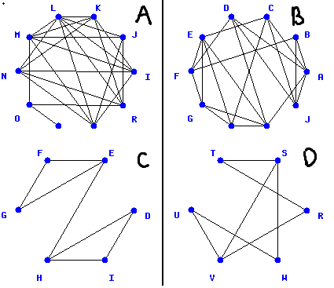

The Hamiltonian cycle (or circuit) is a circuit that visits every vertex once with no repeats. It must start and end at the same vertex. You only care about the vertices, NOT the edges, so you can repeat edges if you so wish.

Choice A: There are 10 vertices, which is more than the required 3, so Dirac’s and Ore’s Theorems are applicable to test for.

$P=1, O=3, N=5, M=6, L=7, K=5, J=4, I=4, R=4, Q=4$

* Dirac’s: Every vertex of *G* must have a degree of at least $v/2=10/2=5$. This is false because vertex *P* does not meet this condition.
* Ore’s: The sum of the degrees of any two non-adjacent vertices *x* and *y* is at least *v* (10). Every case should be checked. (Adjacent means whatever forms an edge with the vertex.)
  + $P+N=1+5=6≥10?$ This is false.
* It’s impossible to get a Hamiltonian cycle because vertex *P* has only 1 degree, which makes it impossible to have in a cycle (you can never move away from that vertex onto the next). **This is NOT a Hamiltonian cycle (don’t check any boxes).**

Choice B: There are 10 vertices, which is more than the required 3. Testing:

$H=4, G=4, F=4, E=5, D=4, C=4, B=3, A=5, J=4, I=5$

* Diarc’s: $v/2=10/2=5$. This is false because most vertices are 4 which is less than 5.
* Ore’s: Every case should be checked.
  + $H+J=4+4=8≥10$? This is false.
* Trying to find a Hamiltonian cycle (an example walk):
$J∼A∼B∼F∼D∼I∼G∼E∼H∼C∼J$

* Thus, **this does have a Hamiltonian cycle**.

Choice C: There are 6 vertices, which is more than the required 3. Testing:

$G=2, F=2, E=3, H=3, D=2, I=2$

* Dirac’s: $v/2=6/2=3$. This is false because vertices *G*, *D*, and *I* are less than 3.
* Ore’s:
  + $G+D=2+2=4≥6?$ This is false then.
* Additionally, there is only one edge connecting the two triangles together, which will make it inevitable for a vertex to be hit more than once when returning to the original beginning vertex.
* **This is NOT a Hamiltonian cycle (don’t check any boxes).**

Choice D: There are 6 vertices, which is more than the required 3. Testing:

$T=2, S=3, R=2, W=2, V=3, U=2$

* Dirac’s: $v/2=6/2=3$. This is false because vertices *U*, *T*, *W*, and *R* are less than 3.
* Ore’s:
  + $T+W=2+2=4≥6?$ This is false then.
* Trying to find a Hamiltonian cycle (an example walk):
$T∼R∼V∼U∼W∼S∼T$

* Thus, **this does have a Hamiltonian cycle**.

**17.** Which of the following graphs are isomorphic?

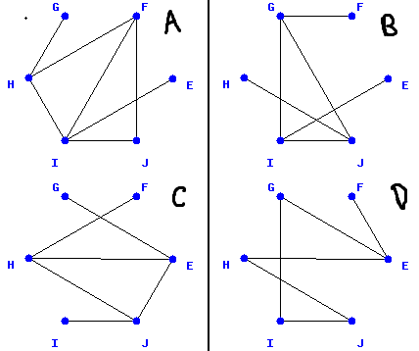

To tell if graphs are isomorphic, the simplest steps to try is whether the number of edges are the same, whether the number of vertices are the same, and if the list of all degrees matches. If one fails, obviously they are not isomorphic; if they all match somehow, you’ll have to correspond a vertex of one graph to a vertex of another. (Note: bijection, so onto and one-to-one.)

Choice A: $n=6, e=7, d=1,3,3,4,1,2⇒(reordered decreasing) 4,3,3,2,1,1$

Choice B: $n=6, e=6, d=1,3,1,1,3,3⇒(reordered decreasing) 3,3,3,1,1,1$

Choice C: $n=6, e=6, d=1,3,3,3,1,1⇒(reordered decreasing) 3,3,3,1,1,1$

Choice D: $n=6, e=6, d=2,2,2,2,3,1⇒(reordered decreasing) 3,2,2,2,2,1$

From these, you can see that Choice B and C match. However, to make sure, you have to check whether the vertices correspond to each other (connect with vertices of the same degree as in the other graph). Here, the vertex of B is listed first in each pair.

$I∼J, E∼I, H∼G, G∼H, F∼F, J∼E$

So, after checking, **BC** are isomorphic.

**18.** Let a graph have vertices $E, F, G, H, I, J, K, L$ and edge set $\{\{E,H\}, \{E,K\}, \{F,G\}, \{F,H\}, \{G,H\}, \{G,I\}, \{G,L\}\}$.

1. What is the degree of vertex *K*?
2. What is the degree of vertex *E*?
3. How many components does the graph have?

Draw out the graph according to the edge set and vertices (when drawing, remember to include all the vertices; vertex *J* isn’t included in the edge set, but it’s included in the vertices):

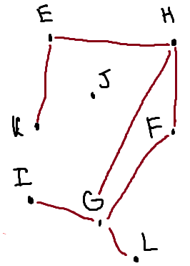

Part A

The degree is **1**. (It also appears one time in the edge set).

Part B

The degree is **2**. (It also appears two times in the edge set).

Part C

There are **2** components due to vertex *J* being excluded and the rest are connected to each other.

**19.** Consider the cities $E, F, G, H, I, J$. The costs of the possible roads between cities are given below:

$c(E,I)=4$

$c(E,J)=9$

$c(F,G)=6$

$c(F,H)=5$

$c(F,I)=3$

$c(F,J)=8$

$c(G,I)=7$

What is the minimum cost to build a road system that connects all the cities?

This is finding the shortest path, but the distances are converted to costs this time. So, first, draw a physical representation of all the possible paths in a graph:

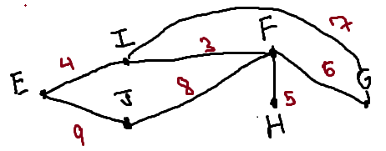

Use Dijkstra’s algorithm to do so. The basic steps include

* Initialization of a vertex to 0 and permanent
* Setting every other vertex to infinity and temporary
* Find the connecting vertices and update them according to the distance so far if the distances are less than the already-printed numbers
* Change the state to permanent if used and designate it as the current vertex
* If all vertices that can be reached are permanent, then stop
* If you cannot reach any temporary labeled vertex from the current, then all temporary labels become permanent
* Once done, go back and see what numbers made up the values

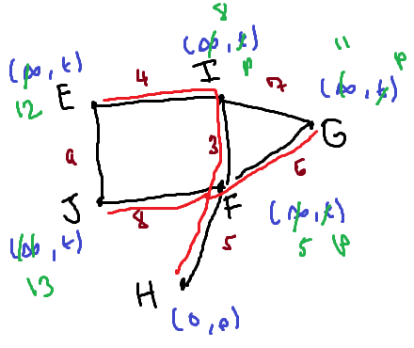

Above is the finished image after running the algorithm. The starting point was H. Adjust the possible vertex pairs and choose the smallest vertex pair to go to and make it permanent for each. Remember to note the edges that make up the distance set by the pairs.

Thus, add the edges included in this red together to get $8+5+6+3+4=$**26**.

**20.** Answer the following questions:

1. How many Hamiltonian circuits are there in a complete graph with 8 vertices?
2. How many Hamiltonian circuits are there in a complete graph with 7 vertices?

A complete graph means that every vertex is adjacent to every other vertex. The adjacency matrix of a complete graph is one whose entries consist of all 1’s except for those along a main diagonal.

The total of non-distinct Hamiltonian circuits in a complete graph is $(n-1)!$, where *n* is the number of vertices. There are a total of *n* edges in a Hamiltonian walk. This is because if you start from one vertex, you have $n-1$ edges to choose from ($n-1$ ways to go to the next vertex).

Divide this number by 2 because each circuit can be counted twice (for example, $A→B→C→A$ is the same as $A→C→B→A$). Thus, you get the formula $\frac{(n-1)!}{2}$.

Part A

Apply the formula to get **2520**.

Part B

Apply the formula to get **360**.

**Note:** An induced subgraph includes subsets of both the vertices and edges as the original graph G, but a general subgraph can have less edges between the same vertices than G.

**Note:** A rooted tree is a tree in which one vertex has been designated as the root. Vertices adjacent to the root are called *children*, in which the root is the *parent*.

* Every vertex has at most one parent.
* The *depth* of a vertex in a rooted tree is defined as the number of edges on the unique path to the root.
* The *height* of a rooted tree is the maximum of the depths of its vertices.
* Example (courtesy of Wolfram MathWorld):

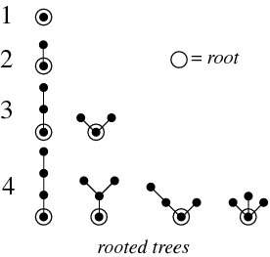

**Note:** The smallest binary tree is an empty rooted tree with no vertices and no edges. A binary tree is a rooted tree where each vertex, viewed as a parent, has at most two children.

* If each vertex has exactly 2 children, then it is a *full binary tree.*
* If a vertex has no children, it is a leaf or an external vertex.
* A binary tree is *complete* if it is full and all its leaves have the same depth.
* [www.mathcs.emory.edu/~cheung/Courses/171/Syllabus/9-BinTree/bin-tree.html](http://www.mathcs.emory.edu/~cheung/Courses/171/Syllabus/9-BinTree/bin-tree.html)